LINCOLN COUNTY RURAL WATER
& SEWER DISTRICT #4
IS REQUESTING THAT YOU!

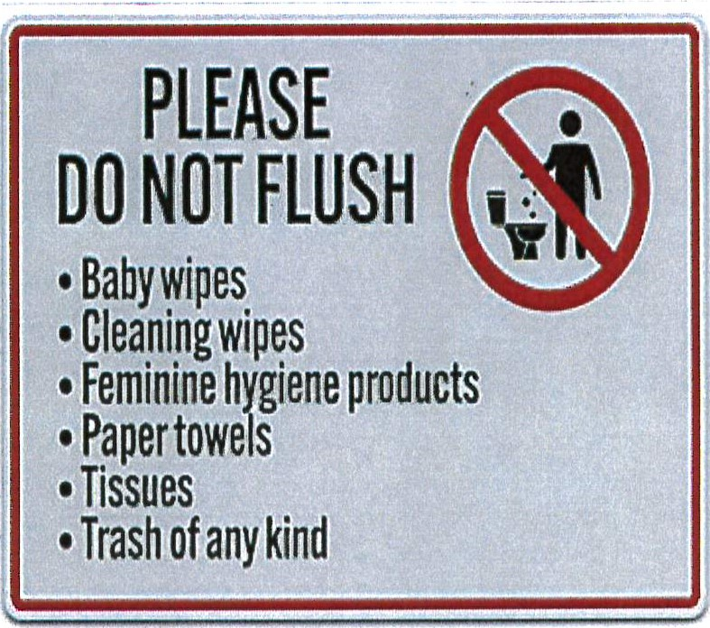

IF YOU HAVE ANY
QUESTIONS, PLEASE CONTACT
THE OFFICE
AT 918-375-2625

